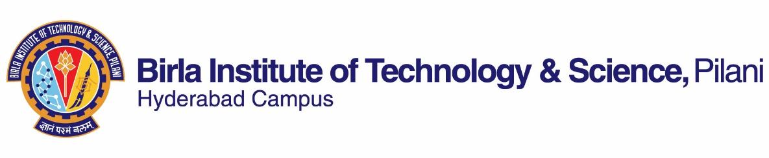

SECOND SEMESTER 2021-2022

COURSE HANDOUT- QUANTUM OPTICS

**Date: 15.01.2022**

**Course No**. **: PHY F420**

# Course Title : Quantum Optics

**Instructor-in-charge**  **: ARANYA B BHATTACHERJEE**

**Instructor**  **: Aranya B Bhattacherjee**

**1. Course Description:** Main topics to be covered in the course include: Quantization of the electromagnetic field both single as well as multimode. Photon statistics and non-classical states of light like photon bunching, anti-bunching and squeezed states of light. Concept of vacuum field, vacuum fluctuations and zero point energy. Concept of coherent states. Semi-classical and full quantum description of atom-field interaction. The Rabi and Jaynes-Cumings model. Beam-splitters and interferometry. Basic laser physics.

**2. Scope and objective:** Quantum optics is one of the important fields in physics at present which is evident from the fact that many Nobel Prizes in the recent past have been given in this field. Light has always fascinated humans and this course will explore the mysteries of quantum light and its interaction with matter. The course will start with the concept of quantizing light which is an electromagnetic field. Elementary concepts of photon statistics will be taught and how one can classify light according to photon statistics, photon bunching and anti-bunching. Students will learn about phasor diagrams and field quadratures, vacuum field, vacuum fluctuations and the zero-point energy. The concept of coherent states, shot noise and number-phase uncertainty and its application to the working of Laser Interferometer Gravitational Wave Observatory (LIGO) will be taught. Photon number states and its application to describe coherent states will be discussed. The students will be exposed to the concept of squeezed states of light, its applications and how it can be generated. After these basic properties of quantized light, the students will learn about the how light interacts with matter. Both semi-classical as well as full quantum model will be used to understand light-matter interaction. Finally the course will end with the basics of how light measurements are made using beam-splitters and interferometers and the students will be exposed to basics of laser physics.

The course will enable students to solve simple problems on photon statistics, light-matter interaction. They will understand and appreciate how the next generation quantum devices are made like all optical switches, quantum computation, quantum networks and quantum communication platforms.

**1.Text Book:** C. Gerry and P. Knight, *Introductory Quantum Optics*, Cambridge University Press, 2005.

**2. Reference Books:** Mark Fox, *Quantum Optics*, Oxford master Series in Atomic, Optical and Laser Physics, Oxford University Press, 2009.

**3. Course Plan:**

|  |  |  |  |
| --- | --- | --- | --- |
| **Lecture Number** | Learning Objectives | Topics to be Covered | **Chapter in the Text Book** |
| **1-12** | Electromagnetic field quantization | Quantization of single and multimode fields. Quantum fluctuations and quadrature operators for a single mode. Thermal fields. Vacuum fluctuations and zero-point energy. | 2.1-2.6 |
| **13-20** | Coherent States | Eigenstates of the annihilation operator and minimum uncertainty states. Displaced vacuum states. Wave packets and time evolution. Properties of coherent states. Phase picture of coherent states. | 3.1-3.3, 3.5-3.6 |
| **21-30** | Emission and absorption of radiation by atoms | Atom-field interactions. Interaction of atom with classical and quantum field. Rabi and Jaynes-Cummings model. | 4.1-4.5 |
| **31-35** | Beam splitters and Interferometers | Experiments with single photons. Quantum mechanics of beam splitters. Interferometry with single photons. Interferometry with coherent states of light | 6.1-6.3, 6.5 |
| **36-42** | Nonclassical light | Quadrature squeezing. Generation of squeezed light. Detection of squeezed light. Amplitude squeezed light. Photon antibunching. | 7.1-7.5 |

**4. Evaluation Scheme:**

|  |  |  |  |  |  |
| --- | --- | --- | --- | --- | --- |
| **EC No.** | Evaluation Component | Duration | **Weight age (%)** | **Date, Time** | **Nature of Component** |
| 1. | Mid-Semester Test | 60 mins. | 30% | 16/03 11.00am to12.30pm | Open Book |
| 3. | Quiz (1) | 30 mins | 15% | NA | Open Book |
| 4. | Assignment (1) | NA | 15% | NA | NA |
| 5. | Comprehensive Examination | 120 mins. | 40% | 19/05 AN | Closed Book |

**5. Notices:** Notices and solutions for examination’s question papers will be displayed on the physics department notice board and/or on CMS website.

**6. Make-up Policy:** Make up may be considered provided a make-up application (for a genuine health issue) forwarded by the Chief Warden is produced. There will be no makeup for Quiz.

**7.** **Academic Honesty and Integrity Policy: Academic honesty and integrity are to be maintained by all the students throughout the semester and no type of academic dishonesty is acceptable.**

Aranya B Bhattacherjee

**Instructor-in-charge**